ADVISORY BOARD

- Prof. Mohd .Arif ,University of Wolve Hampton ,U.K
- Dr. Saurav Goel , Cranefield University ,U.K
- Dr. M.N. Khan , Al Majmah University ,Kingdom of S.A.
- Prof. Waqar Ahamad Khan, AlMajmah University, Kingdom of S.A..
- Dr.Zahir Hassan,Jazan University, University of S.A.
- Dr.Nitin Upadhayay , University of Modern Science ,Dubai (UAE)
- Dr.DevineJ r.Berk , Berkeley, University of California (US)
- Dr . Robert Prakash ,Stanford University ,USA
- Dr.Peeyush Soni, AIT, Pathumthani, Thailand
- Dr.Vipul Jain, Victoria University of Wellington, New Zealand
- Prof. Rajesh Prasad ,I.I.T., Delhi
- Prof. Puneet Mahajan ,I.I.T., Delhi
- Prof. P.M Pandey , I.I.T.,Delhi
- Prof. U.S Rao ,I.I.T., BHU
- Prof. Mohd. Zaheer Khan Yousufzai ,I.I.T., BHU
- Prof. I.V Singh ,I.I.T. , Roorkee
- Dr.V.Manoj Kumar I.I.T. ,Roorkee
- Prof. Rajeev Kumar ,I.I.T.,Mandi
- Dr. Sachin Kumar ,I.I.T., Ropar
- Prof. Dr. A.K. Agarwal, I.I.T, BHU
- Dr.Amit Tyagi, I.I.T., BHU
- Prof. K.N. Pandey, MNNIT, Allahabad
- Dr. Rajeev Srivastava, MNNIT, Allahabad
- Prof. Naveen Kumar ,DTU Delhi
- Prof. Rajesh Agarwal ,DTU Delhi
- Prof. R.S Walia ,DTU,Delhi
- Prof. Sanjay Kumar ,DTU ,Delhi
- Prof. Dixit garg ,NIT ,Kurushetra
- Dr.Hari Singh ,NIT ,Kurushetra
- Dr.Jatinder Kumar ,NIT ,Kurushetra
- Prof. Punit Kumar ,NIT ,Kurushetra
- Prof. Gulshan Sachdeva ,NIT ,Kurushetra
- Dr.Amitesh Kumar, NIFFT, Ranchi
- Dr. Raj Kumar Sahu ,NIT ,Raipur
- Dr.Prabha Chand ,NIT ,Jamshedpur
- Dr. Siddhartha Vashishtha, NIT, Hamirpur
- Dr.Somesh Kumar Sharma , NIT ,Hamirpur
- Dr. Rajesh Sharma, NIT ,Hamirpur
- Prof. Mohd .Islam , J.M.I. ,Delhi
- Prof. M.M Hasan ,J.M.I.,Delhi
- Prof. Z.A.Khan , J.M.I. ,Delhi
- Prof .Arshad Noor Siddiquee ,J.M.I., Delhi
- Dr. Rajesh Mishra, BITS, Pilani
- Dr . Rahul O. Vaisya, PEC Chandigarh
- Dr.Balasubramanian K. ,DIAT Pune
- Dr. M.K. Singh, KEC, Ghaziabad
- Mr. Satendra Srivastava, GM, TBI, KIET
CONFERENCE SECRATRIAT
CHIEF PATRON
Mr. M. P. Jain
Honourable Chairman
KIET Group of Institutions, Ghaziabad

PATRON
Dr. (Col) A. Garg
Director
KIET Group of Institutions, Ghaziabad

CONVENER
Dr. Kunwar Laiq Ahmad Khan
Professor & Head
Department of Mechanical Engineering
KIET Group of Institutions, Ghaziabad

CO-CONVENERS
Dr. Ashish Karnwal
Dr. Rupesh Chalisgaonkar

ORGANISING SECRATORY
Dr.Arunesh Chandra
Dr.Pratibha Kumari
Dr. S. K. Sharma
Dr. Anurag Gupta
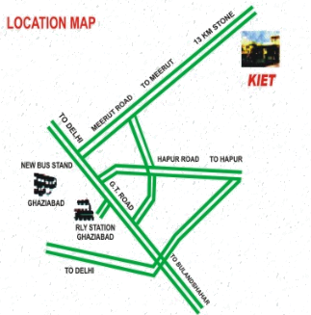

ICRTIME-2018
Two days International Conference
on
Recent Trends and Innovations
in
Mechanical Engineering
20th-21st July, 2018

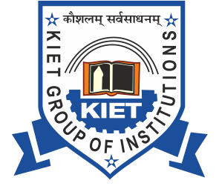
Organized by
Department of Mechanical Engineering
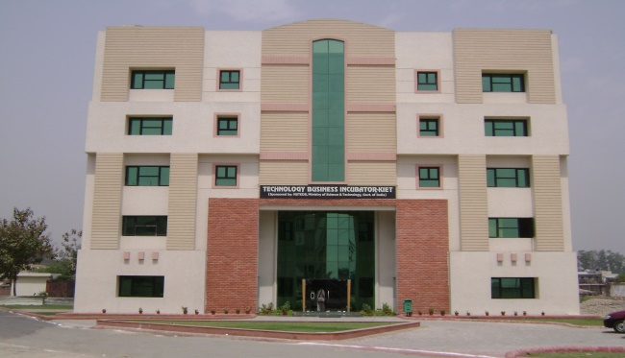
KIET Group of Institutions, Ghaziabad
(Accredited by NBA & NAAC with ‘A’ Grade)
13 Km. Stone, Ghaziabad - Meerut Highway,
NH-58, Ghaziabad, Uttar Pradesh 201206
In association with TBI (KIET)
Sponsored by

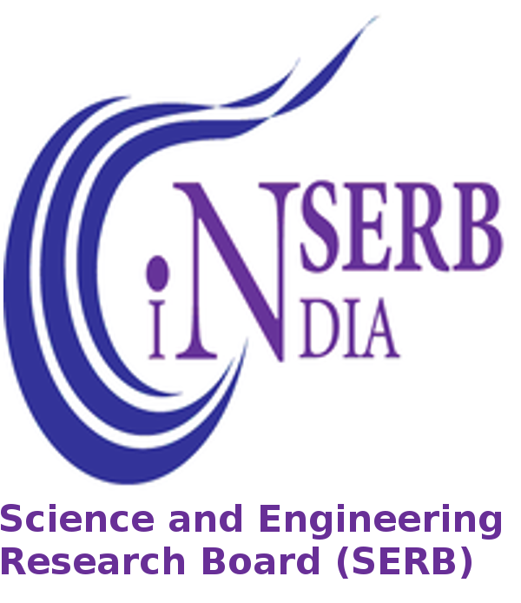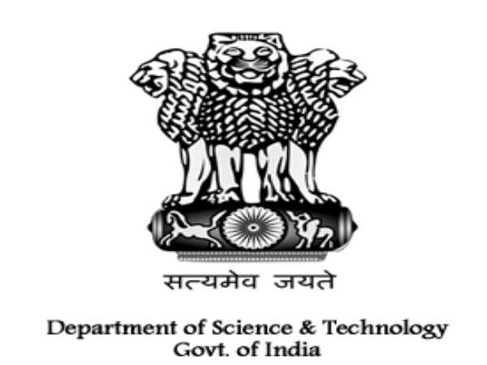
Science and Engineering Research Board (SERB)
Department of Science and Technology (DST)
Govt. of India

ABOUT KIET
KIET Group of Institutions was established in 1998 by Krishna Charitable Society at Ghaziabad (U.P.). The institution is affiliated to Dr. A.P.J. Abdul Kalam Technical University, Lucknow. KIET is imparting Technical education and enjoying reputation by maintaining all norms and standards of quality education by virtue of which it was awarded ISO-9000-2008 certification, Star performer in terms of its faculty, infrastructure, results and placements. The Institute offers B. Tech degree courses in Mech. Engg., Computer Sc. & Engg., Electronics & Comm. Engg., Elect. & Electronics Engg, Electronics &Inst Engg., IT, Civil Engg., and MBA, MCA & M. Tech. Courses to meet varied aspirations of students. Recently NAAC has accredited KIET with Grade A for a period of five years.
ABOUT ME DEPARTMENT
The Mechanical Engineering Department of KIET has a reputation of being among the finest in the state and is dedicated towards the advancement of technology and science. The department was established in 1999 with the objective to impart quality education in the core field of Mechanical Engineering. The department was accredited in the year 2005, 2009 and 2015 by National Board of Accreditation (NBA) of AICTE. The department has an excellent industrial interaction and contributes to the industry by offering consultancy services.
ABOUT THE CONFERENCE
Today, we need innovators more than any time before. Every organization and business is feeling the impact of globalization, migration, technological and knowledge revolutions, and climate change issues. Innovation will bring added value and widen the employment base.
The present conference attempt to establish some robust and mutual interactions and cooperation with scientific educational, governmental and non-governmental organizations, and industries across local, national and international levels to meet the following objectives:
- Creating contacts as possible to provide a means for scientific and industrial exchanges.
- Boosting the scientific and research collaborations with other scientific centers in the country and around the world.
- Promoting the basic and applied research in mechanical engineering, identifying the top ideas and turning them into productive projects.
- Strengthening the interaction and communication between educational institutions and the industries.
- Finding out the latest scientific achievements and research methods.
- To encourage academicians for doing more research work and innovations.

PARTICIPATION
The Conference is aimed at an exchange of ideas and concepts among a broader group including:
- Academicians
- Students
- Entrepreneurs and Business Leaders
- Representatives from Industries
- Representatives from Government and Investment Organizations
- Innovators
CALL FOR PAPERS
The research paper is to be submitted in MS Word in the prescribed format through conference website “website name” by clicking on the link “submit paper”. The research paper can also be submitted at E-mail id: “icrtime2018@gmail.com”. After the acceptance, authors are requested to register. Only registered papers will be eligible for publishing.
THEMES OF CONFERENCE
The conference will highlight the related focused areas based on the following themes / topics
- Engineering Design
- Modelling and Simulation
- Automotive Industry
- Smart and composite materials
- Nano-Science
- Aerospace and Aeronautical Engineering
- Measurement and Inspection
- Tribology
- Ergonomics
- Quality Management
- Production Management
- Maintenance, Logistics
- Manufacturing Processes
- Intelligent Manufacturing Systems
- Automation and Mechtronics/Robotics
- Modelling& Optimization of Systems and Processes
- Medical Innovative Technologies
- Environment in manufacturing
- Biotechnology and Bioengineering
- Agriculture Innovative Technologies
- Energy, Energy plants, Thermal Engineering
- Renewable and Non conventional Energy Sources
- CAD/CAM/FMS/CIMS
- FEM/FEA
(Any other paper related with the theme of the conference
will be accepted)

IMPORTANT DATES
Abstract Submission Deadline | 25th May’2018
Acceptance of abstract | 30th May’2018
Full Paper Submission Deadline | 15th Jun’2018
Acceptance of Full Paper | 25th Jun’2018
Last Date of Registration | 30th Jun’2018
Date of conference | 20th-21stJuly2018

REGISTRATION FEE
CATEGORY | NATIONAL DELEGATES  (INR) | INTERNATIONAL DELEGATES  (USD)
Delegates from Industry | 3500 | 160
Delegates from Academic Institutions | 2500 | 100
Research scholars/Students | 1500 | 75
For Attending Only | 1000 | 50

MODE OF PAYMENT
Payment through demand draft in favour of KIET GROUP
OF INSTITUTIONS payable at GHAZIABAD
Online Payment through NEFT/RTGS:
 | For National Delegates | For international Delegates
Name | KIET Group of Institutions | Krishna Institute of Engineering & Technology
A/C NO. | 508011003720 | 125601000763
IFSC Code/SWIFT Code | KKBK0005295 | ICICINBBCTS
Bank Name | Kotak Mahindra Bank | ICICI Bank Ltd.
Branch | Navyug Market,  Ghaziabad 201001 | Ambedkar Road,Opp. Nehru Yuva Kendra,Ghaziabad 201001

